**MIP User Administration Page**

This single page manages the group of users for the MIP application. There are five types of users and seven different types of views that each user may or may not have access to:

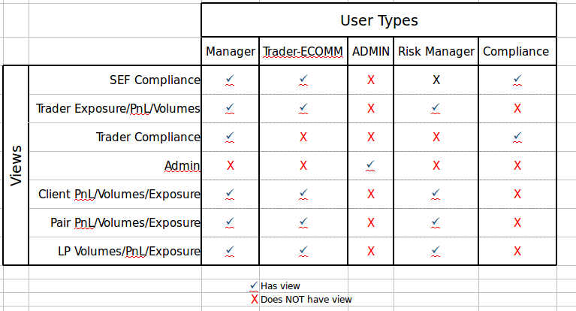

In addition to a User Type, each user has the following associated with them:

1. Region: can be Chicago, London or Singapore. Note that we may need to add more regions as time goes on.
2. Secrecy flag: true/false
3. Password
4. User ID: integer index from database
5. User name

This page needs to do the following:

1. Add a new user.
2. Delete an existing user.
3. Change a user’s password.
4. Change a user’s role or “User Type”. i.e. change user #356 from “Compliance” to “Manager”
5. Change a user’s Region

Where necessary, assume that you can query a RESTful web API via an AJAX call to obtain JSON data to populate the page.